100 Books to read in Year 5 and 6
https://theteachingbooth.wordpress.com/2018/07/25/the-new-and-slightly-improved-100-books-to-read-in-5-6/
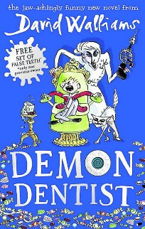  Demon Dentist  David Walliams | 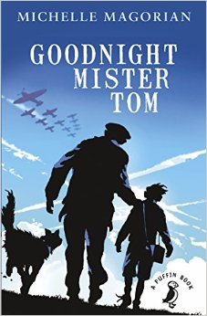  Goodnight Mister Tom  Michelle Magorian | 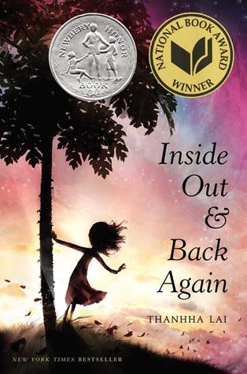  Inside Out and Back Again  Thannha Lai | 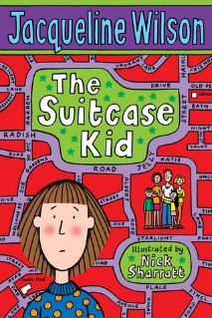  The Suitcase Kid  Jacqueline Wilson | 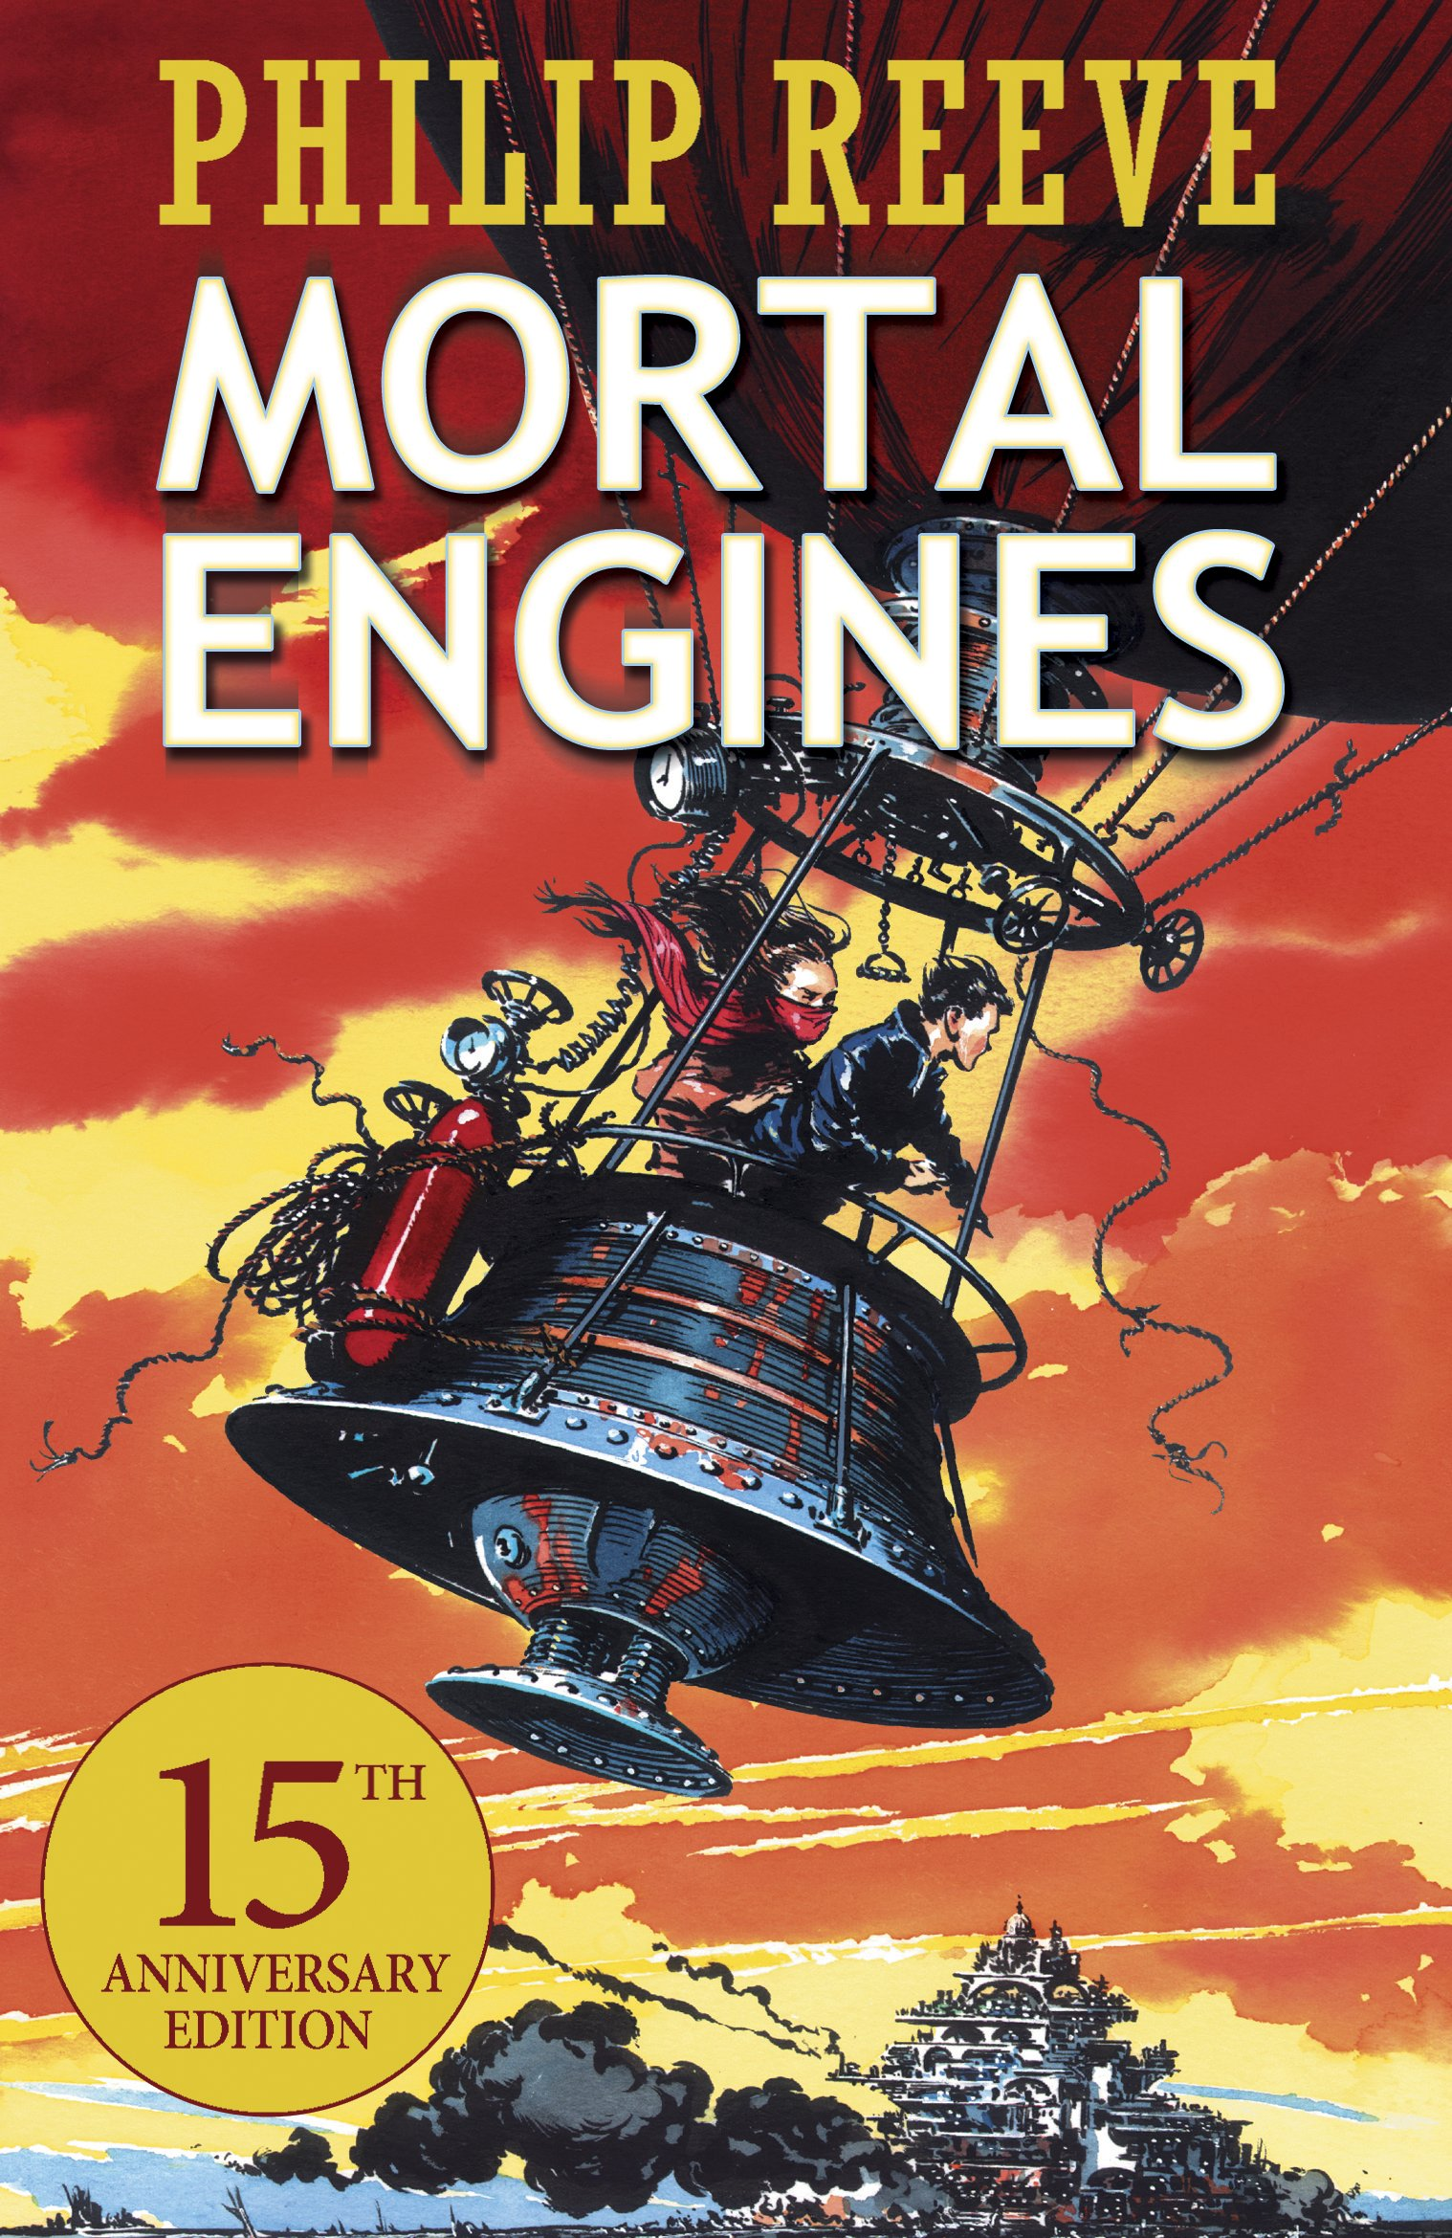  Mortal Engines  Philip Reeve | 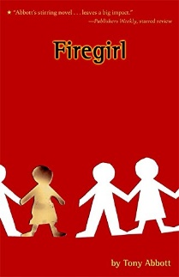  Firegirl  Tony Abbott | 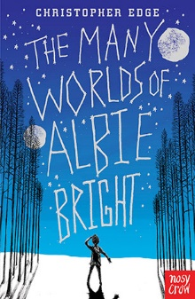  The Many Worlds of Albie Bright  Christopher Edge
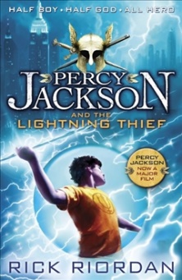  Percy Jackson and the Lightning Thief  Rick Riordan | 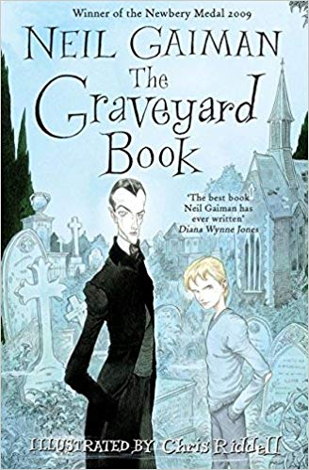  The Graveyard Book  Neil Gaiman | 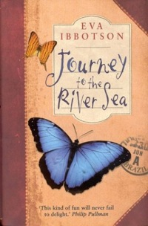  Journey to the River Sea  Eva Ibbotson | 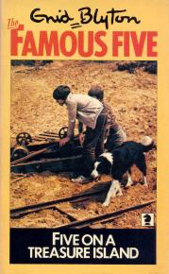  Five On A Treasure Island  Enid Blyton | 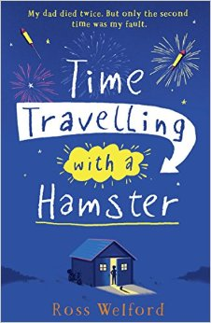  Time Travelling with a Hamster  Ross Welford | 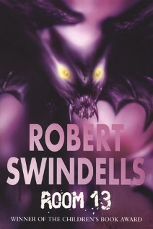  Room 13  Robert Swindells | 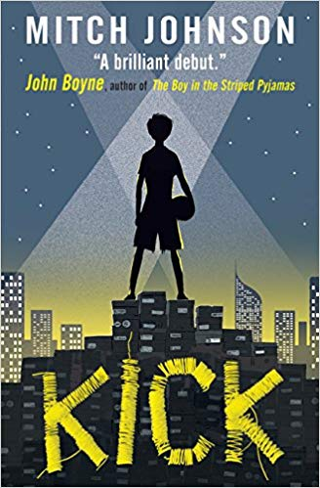  Kick  Mitch Johnson
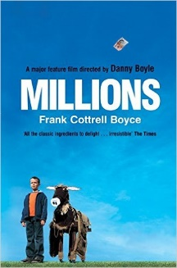  Millions  Frank Cottrell-Boyce | 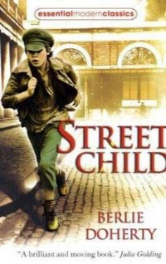  Street Child  Berlie Doherty | 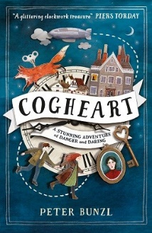  Cogheart  Peter Bunzl | 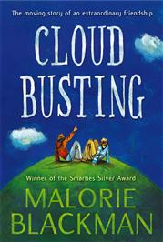  Cloud Busting  Malorie Blackman | 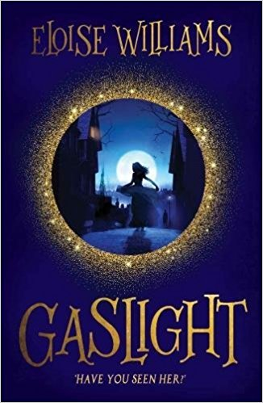  Gaslight  Eloise Williams | 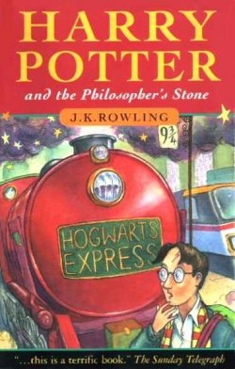  Harry Potter and the Philosopher’s Stone  J.K. Rowling | 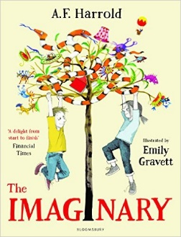  The Imaginary  A.F. Harrold

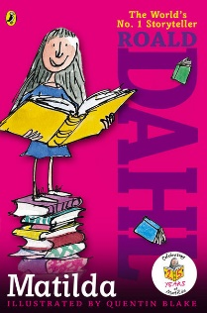  Matilda  Roald Dahl | 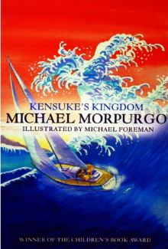  Kensuke’s Kingdom  Michael Morpurgo | 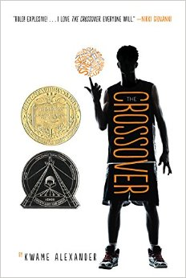  The Crossover  Kwame Alexander | 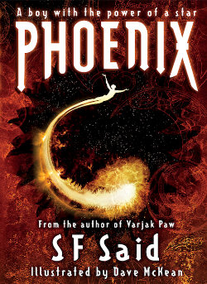  Phoenix  S.F. Said | 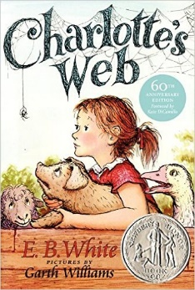  Charlotte’s Web  E.B. White | 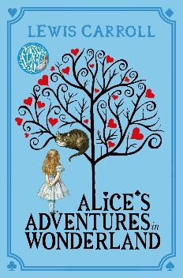  Alice’s Adventure’s in Wonderland  Lewis Carroll | 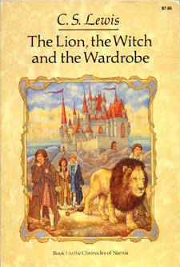  The Lion, The Witch and The Wardrobe  C.S. Lewis
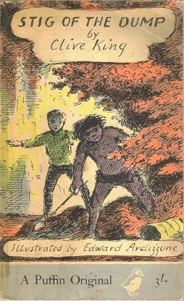  Stig of the Dump  Clive King | 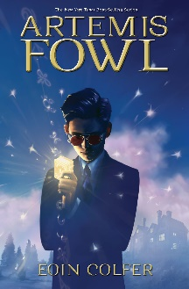  Artemis Fowl  Eoin Colfer | 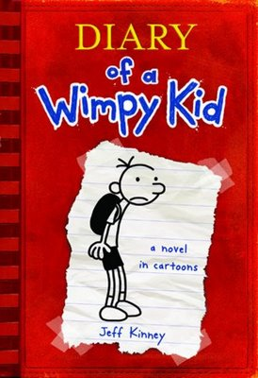  Diary of a Wimpy Kid  Jeff Kinney | 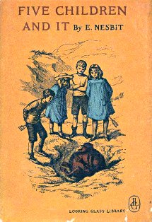  Five Children and It  E. Nesbit | 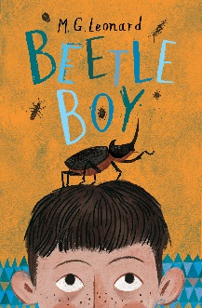  Beetle Boy  M.G. Leonard | 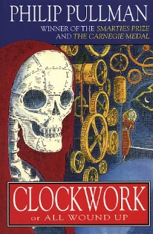  Clockwork  Philip Pullman | 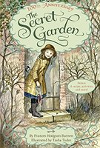  The Secret Garden  Frances Hodgson Burnett
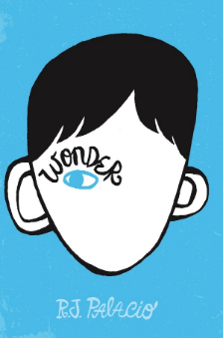  Wonder  R.J. Palacio | 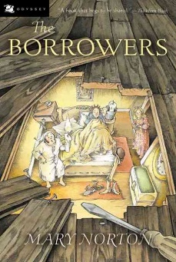  The Borrowers  Mary Norton | 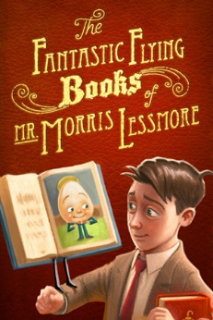  The Fantastic Flying Books of Mr Morris Lessmore  W.E. Joyce | 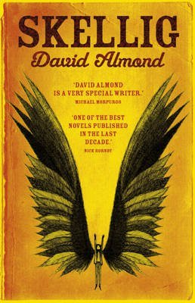  Skellig  David Almond | 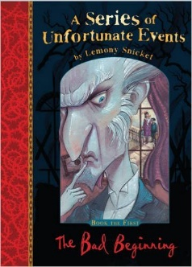  A Series of Unfortunate Events  Lemony Snicket | 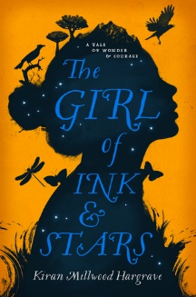  The Girl of Ink and Stars  Kiran Millwood Hargrave | 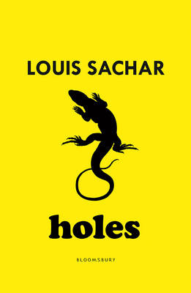  Holes  Louis Sachar

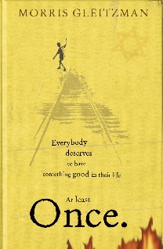  Once  Morris Gleitzman | 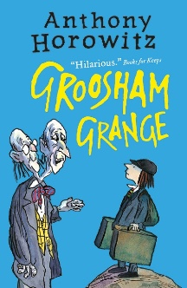  Groosham Grange  Anthony Horowitz | 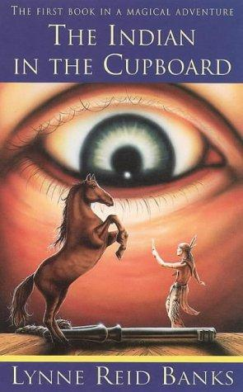  The Indian in the Cupboard  Lynne Reid Banks | 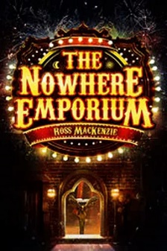  The Nowhere Emporium  Ross Mackenzie | 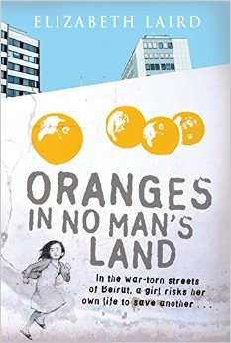  Oranges in No Man’s Land  Elizabeth Laird | 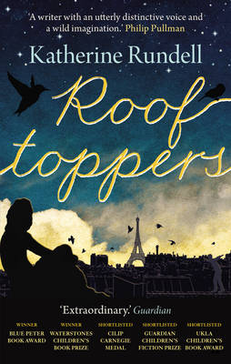  Rooftoppers  Katherine Rundell | 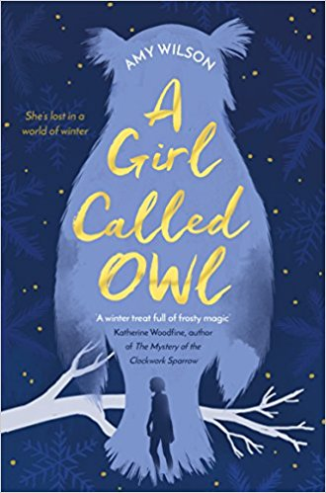  A Girl Called Owl  Amy Wilson
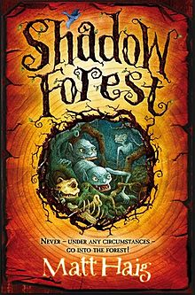  Shadow Forest  Matt Haig | 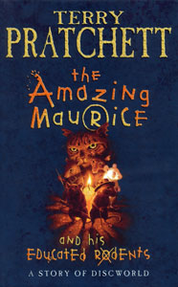  The Amazing Maurice  Terry Pratchett | 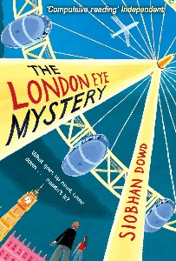  The London Eye Mystery  Siobhan Dowd | 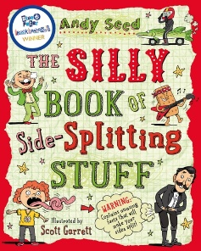  The Silly Book of Side-Splitting Stuff  Andy Seed | 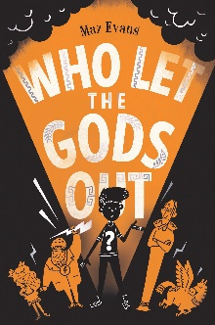  Who Let the Gods Out  Maz Evans | 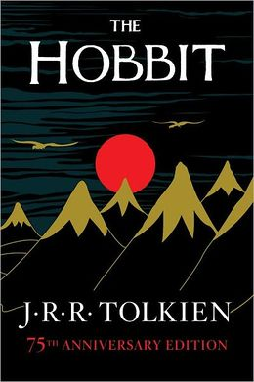  The Hobbit  J.R.R. Tolkien | 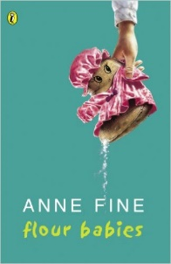  Flour Babies  Anne Fine
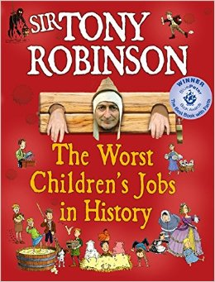  The Worst Children’s Jobs in History  Tony Robinson | 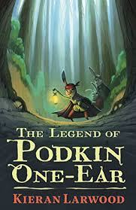  The Legend of Podkin One-Ear  Kieran Larwood | 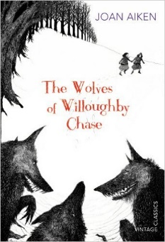  The Wolves of Willoughby Chase  Joan Aiken | 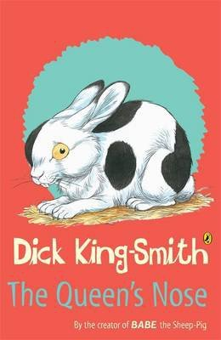  The Queen’s Nose  Dick King-Smith | 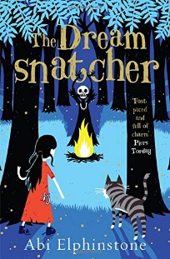  The Dream Snatcher  Abi Elphinstone | 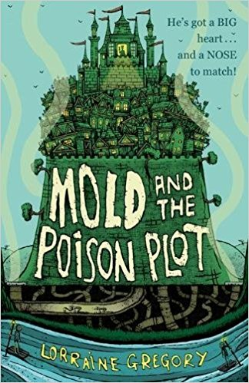  Mold and the Poison Plot  Lorraine Gregory | 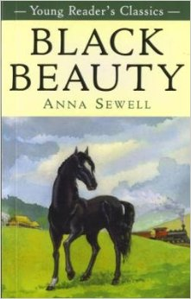  Black Beauty  Anna Sewell

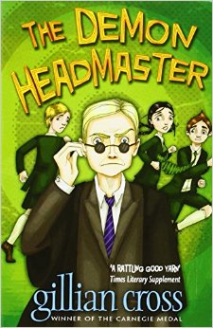  The Demon Headmaster  Gillian Cross | 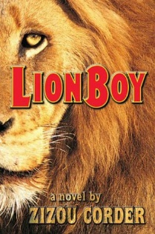  Lion Boy  Zizou Corder | 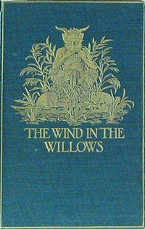  The Wind in the Willows  Kenneth Grahame | 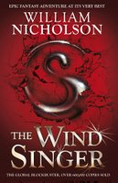  The Wind Singer  William Nicholson | 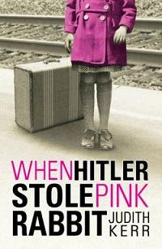  When Hitler Stole Pink Rabbit  Judith Kerr | 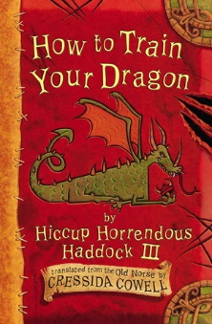  How to Train Your Dragon  Cressida Cowell | 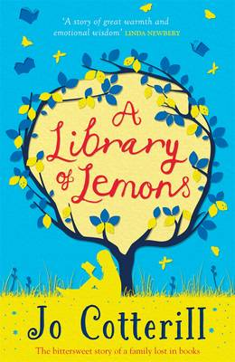  A Library of Lemons  Jo Cotterill
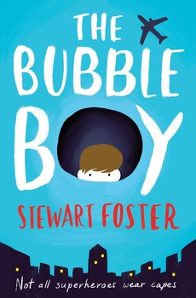  The Bubble Boy  Steward Foster | 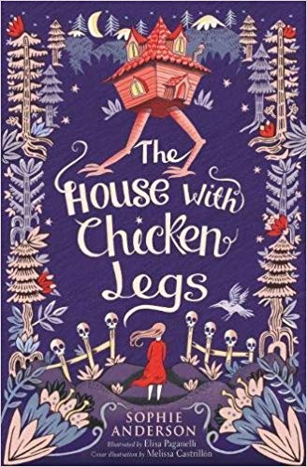  The House with Chicken Legs  Sophie Anderson | 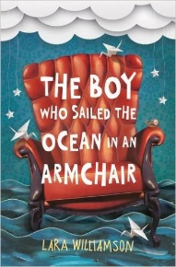  The Boy who Sailed the Ocean in an Armchair  Lara Williamson | 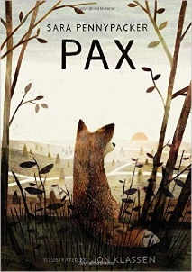  Pax  Sara Pennypacker | 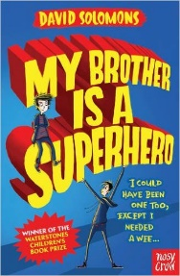  My Brother is a Superhero  David Solomons | 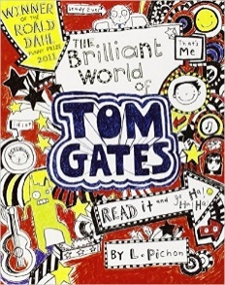  The Brilliant World of Tom Gates  Liz Pitchon | Black Powder  Ally Sherrick
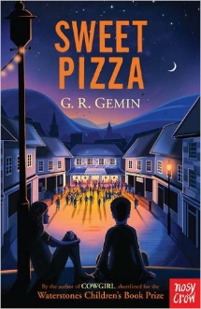  Sweet Pizza  G.R. Gemin | 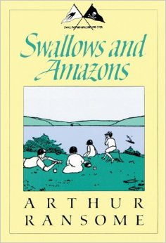  Swallows and Amazons  Arthur Ransome | 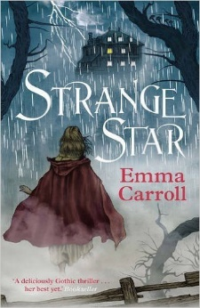  Strange Star  Emma Carroll | 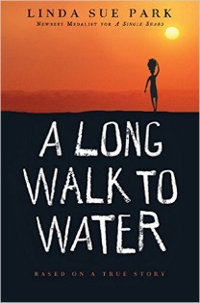  A Long Walk to Water  Linda Sue Park | 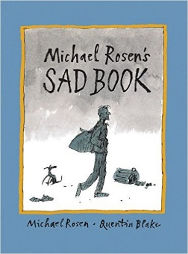  Michael Rosen’s Sad Book  Michael Rosen | 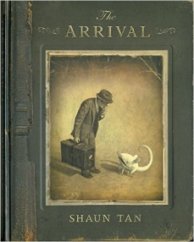  The Arrival  Shaun Tan | 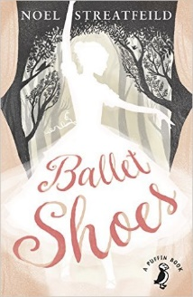  Ballet Shoes  Noel Streatfeild

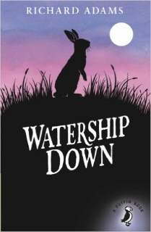  Watership Down  Richard Adams | 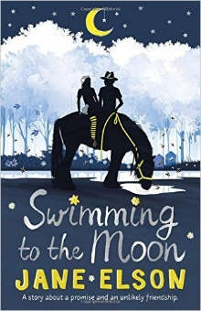  Swimming to the Moon  Jane Elson | 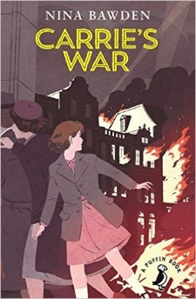  Carrie’s War  Nina Bawden | 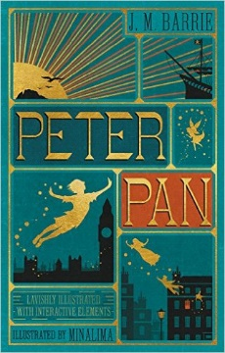  Peter Pan  J.M. Barrie | 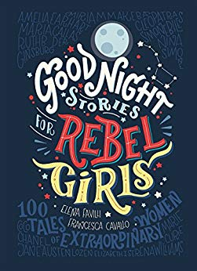  Good Night Stories for Rebel Girls  Elena Favilli | 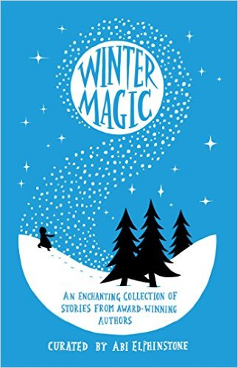  Winter Magic  Abi Elphinstone | 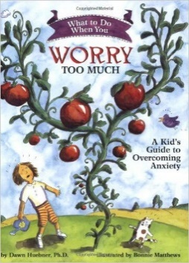  What to do when you worry too much  Dawn Huebner
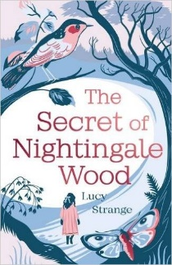  The Secret of Nightingale Wood  Lucy Strange | 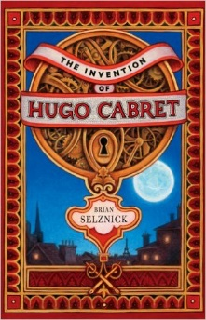  The Invention of Hugo Cabret  Brian Selznick | 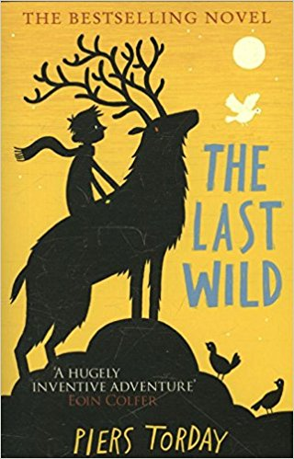  The Last Wild  Piers Torday | 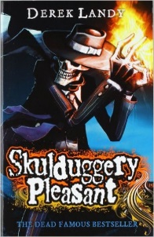  Skulduggery Pleasant  Derek Landy | 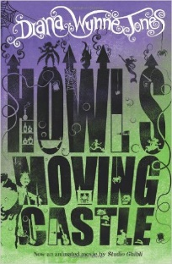  Howl’s Moving Castle  Diana Wynne Jones | 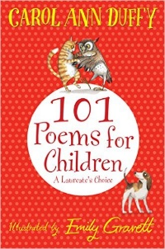  101 Poems for Children  Carol Ann Duffy | 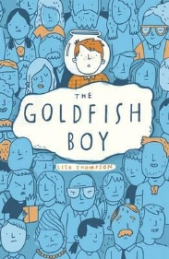  The Goldfish Boy  Lisa Thompson
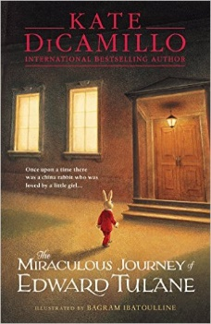  The Miraculous Journey of Edward Tulane  Kate DiCamillo | 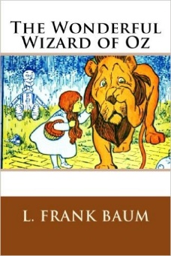  The Wonderful Wizard of Oz  Frank L. Baum

