Further ideas for Charlie and the Chocolate Factory:

Chapters 23 and 24:
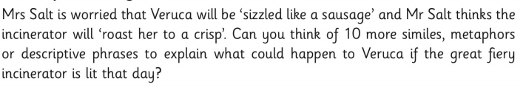

Chapter 25 and 26:
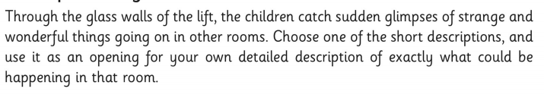
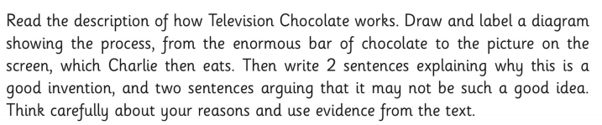
Chapters 27 and 28:
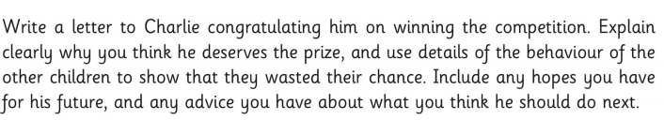
Chapters 29 and 30:
